Program 1

Deploy Files to Github via GIT

Prerequisite

Install gitbash software

<https://git-scm.com/downloads>

To check the public key is configured or not

Key creation

Click on settings

If key is already there in github account- don’t change any thing

Step : if key not there follow steps

Follow the steps to generate RSA Key

Public key generation

Click on ssh

Give some name like key23

So we need to generate key

Steps to generate key

Cd .ssh



ssh-keygen -t rsa

ls

To view public key

cat id-rsa.pub

Copy code with no blank spaces

And paste in git hub key

Again login

It is the process of verifying key is available in github.com

If key is not there generate key by following steps

To deploy files via Git Bash to Git hub repository

Use ctrl + l to clear screen

Create new repository in github.com

git clone [git@github.com:sriharshaklu/library-management.git](mailto:git@github.com:sriharshaklu/library-management.git)

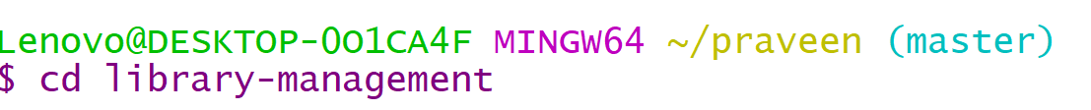

To create files

Use touch file name.extension

To add content in the file

Use command

Vi filename.extension

If you want to want to write

Press insert button in key board

After writing the code

If you want to close vi prompt

Press esc button

Then type

:wq

Press enter

To come to main prompt i.e $



Before adding files check git status – files are in red color

The apply command

git add .

files are green color indicates that added to github repository

Refresh the github repository page

Click on HelloWorld.java

Then create pipeline in azure to build java program